



Government of Maharashtra

School Education and Sports Department

State Council of Educational Research & Training, Maharashtra

**708, Sadashiv Peth, Kumthekar Road, Pune 411030**

Telephone (020) 2447 6938 E-mail: [positionpapers@maa.ac.in](mailto:positionpapers@maa.ac.in)

**------------------------------------------------------------------------------------------------------------------------------------**

**Procedure to give your contribution for Position Papers for**

**New Education Policy 2020**

<https://scertmaha.ac.in/positionpapers/>

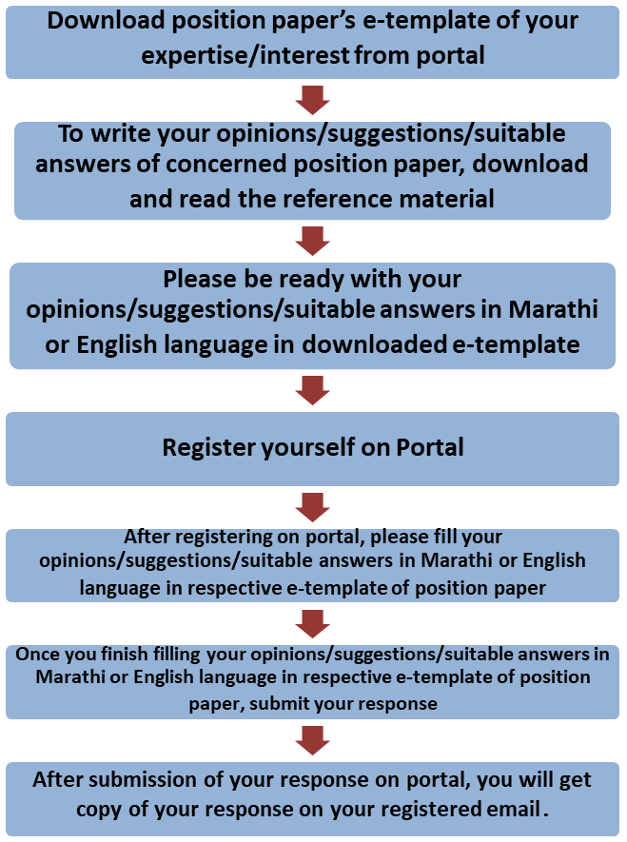

Last date of filling of your response is 30th May 2022

**Curriculum Development Department,**

**State Council of Educational Research and Training, Maharashtra, Pune**

# Linkage between School Education and Higher Education e-Template for Position Paper of the Focus Group

1. **Preliminary information**

This section contains preliminary information regarding the focus group.

* 1. **Executive Summary/Abstract** (1-500 words)

1. **Introduction**
   1. **Present Status of Linkage between School Education and Higher Education** *(What is the present status/position regarding Linkage between school education and higher education? This also needs to include a brief on historical perspective and prevailing practices at the National or State or UT level.)* (1-300 words)
   2. **National Education Policy 2020 and Linkage between School Education and Higher Education** *(Please respond to the NEP 2020 points on Linkage between school education and higher education, including any suggestions you may have regarding additions or modification. #1)* (1-300 words)
   3. **Current Challenges** *(What are the problems currently faced in the area of linkage between school education and higher education that must be addressed? #2)* (1-500 words)
   4. **Addressing Current Challenges** *(How can we ensure that the problems listed in 2.3 are addressed/overcome? What is currently being done well in linking school education and higher education, and how can these present good practices/innovations/initiatives be strengthened/scaled up? #3 and #4)* (1-500 words)

## **Current Best Practices** (Do any kind of linkages already exist between school education and higher education? If yes, how can they be strengthened? *#*5) (1-100 words)

1. **Continuity between Curriculum and Learning Experiences** *(How can continuity be maintained between the curriculum and learning experiences of school and higher education to ensure that the overall aims of education are achieved? What kind of learning experiences in school education will prepare learners for higher education? #6)* (1-500 words)
2. **New Design of the Secondary Stage as per NEP 2020 *(****What should be the broad design of the Secondary Stage such that it prepares the ground for multidisciplinary, choice- based, flexible undergraduate education? #7)* (1-300 words)
3. **Role of Higher Education Institutions** *(What steps should be taken by higher education institutions to support the transition of students from school into higher education? What kind of academic, financial, socio-emotional support should higher education institutions provide for this? #8)* (1-300 words)
4. **Coordination Mechanism between Higher Education and School Education** *(What are the coordination mechanisms envisaged between higher education and school education to ensure that there is a continuous link between teacher education programmes and the school system? #9)* (1-500 words)
5. **Special Education Zones** *(How should Special Education Zones (SEZ) be identified? How will it be ensured that both high quality school and higher education opportunities are provided in these areas? #10)* (1-300 words)
6. **Enabling Conditions for Linking School Education and Higher Education** *(What other enabling conditions (e.g., school culture, practices, infrastructure, equipment, governance, etc.) should be in place in order to effectively enable all the above transformations? #11)* (1-300 words)

## Foundational stage (1-200 words)

* 1. Preparatory stage (1-200 words)
  2. Middle stage (1-200 words)
  3. Secondary stage
     1. Classes IX and X (1-200 words)
     2. Classes XI and XII (1-200 words)

1. **Impact of Credit Transfer System on School Education** *(How would the Credit-transfer system, which is being implemented in higher education, have an impact on school education? Will it be feasible to implement Credit Transfer Systems in Schools as well? If yes, at what stage and how? #12)* (1-200 words)
2. **Role of Various Agencies in linking School Education and Higher Education** *(What roles, various agencies for example, SIETs, SCERTs, DIETs, CTEs, IASEs, NIEPA, NCERT, KVS, NVS, CBSE, School Education Boards, UGC, Universities, CSR initiatives, philanthropic organizations, NGO, SIEMAT, local administration etc., can play in linking school education and higher education?)* (1-200 words)

## Local organisations (1-200 words)

* 1. State level organisations (1-200 words)
  2. National level organisations (1-200 words)
  3. Any other (1-200 words)

1. **Specific Recommendations for the National/State Curriculum Frameworks** *(What are your specific recommendations for four curriculum frameworks with regard to linkages between higher education and school education?)* (1-300 words)

## Specific recommendations for NCF/SCF ECCE (1-200 words)

* 1. Specific recommendations for NCF/SCF SE (1-200 words)
  2. Specific recommendations for NCF/SCF TE (1-200 words)
  3. Specific recommendations for NCF/SCF AE (1-200 words)

1. **Any other Comments and Suggestions on this Theme** *(In this subsection, please provide other suggestions about Linkage between school education and higher education that are not covered in the above questions. It is recommended that these suggestions are in alignment with the vision and specific anchors provided above from the NEP 2020).* (1- 200 words)

# Bibliography and References

(Please include references (research papers, studies, pilots, or anecdotal evidence) throughout to help substantiate recommendationswherever applicable. A bibliography would also be most helpful foreasy reference.)

(Here, the system will allow the user to insert references in the APA format while filling up the document and will collate all the references in this section.)

## Filled by system.

Annexures

(Not mandatory. Please put in a title for an annexure along with a one- line description)