



Government of Maharashtra

School Education and Sports Department

State Council of Educational Research & Training, Maharashtra

**708, Sadashiv Peth, Kumthekar Road, Pune 411030**

Telephone (020) 2447 6938 E-mail: [positionpapers@maa.ac.in](mailto:positionpapers@maa.ac.in)

**------------------------------------------------------------------------------------------------------------------------------------**

**Procedure to give your contribution for Position Papers for**

**New Education Policy 2020**

<https://scertmaha.ac.in/positionpapers/>

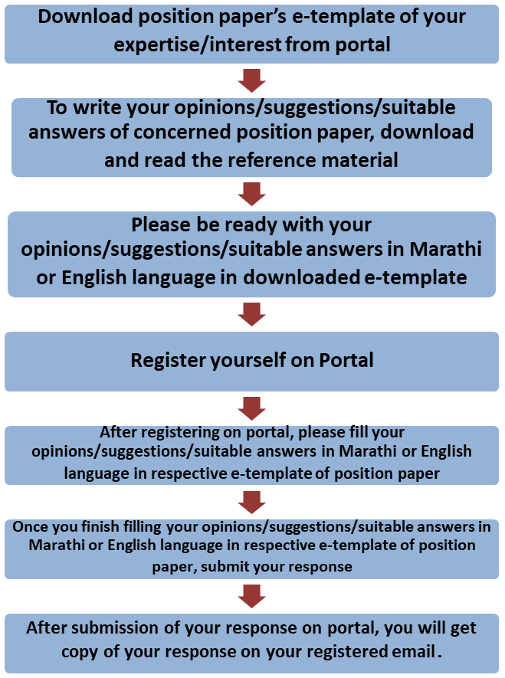

Last date of filling of your response is 30th May 2022

**Curriculum Development Department,**

**State Council of Educational Research and Training, Maharashtra, Pune**

# Mathematics Education and Computational Thinking e-Template for Position Paper of the Focus Group

1. **Preliminary information**

This section contains preliminary information regarding the focus group.

* 1. **Executive Summary/Abstract** (0-500 words)

1. **Introduction**
   1. **Introduction to Mathematics Education and Computational Thinking** (*What is the present status/position regarding Mathematics Education? This also needs to include a brief on historical perspective and prevailing practices at the National or State or UT level.)* (0 – 500 words)
   2. **National Education Policy 2020 and Mathematics Education (***Please respond to the NEP 2020 on Mathematics Education and Computational Thinking, including any suggestions you may have regarding additions or modification-#1)* (0-300 words)
   3. **Current Challenges (***What are the problems currently faced in the curriculum and pedagogy of Mathematics? #2*) (0-500 words)
   4. **Addressing Current Challenges** *(How can we ensure that the problems listed in 2.3 are addressed/overcome? What is currently being done well in Mathematics Education, and how can these present good practices/innovations/initiatives be strengthened/scaled up? #3 and #4)* (0-500 words)

# Mathematics Curriculum and Pedagogy: Cross Cutting themes

* 1. **Mathematics and Computational Thinking Curriculum** (H*ow will the challenges (raised in 2.3) be addressed in the new curriculum towards making it flexible and horizontally cross cutting across different curricular areas #5?*) (0-800 words)
  2. **Mathematics Curriculum for Digital Literacy (***What would be the approach to integrating digital literacy in the early years of mathematics education#8?)* (0-500 words)
  3. **Integrating Indian Knowledge Systems in Mathematics Curriculum *(****How will Indian knowledge systems be incorporated into the mathematics curriculum? How would the contribution of India to the world of mathematics be addressed in the curriculum? How would the content of mathematics – e.g. games, puzzles, problems to be solved-be rooted in the Indian context?# 11, 13)* (0-500 words)
  4. **Integrating Computational Thinking and Computer Programming (***How would computational thinking and computer programming be introduced in the Middle and Secondary school stages?#9*) (0-300 words)
  5. **Mathematics Curriculum for 21st Century** (*How can the mathematics curriculum be made more engagig, multidisciplinary, and its learnings relevant to the child and help in developing 21st-century skills? What are other subject areas under the Mathematics Education and Computational Thinking that should be introduced at the secondary stage to fulfil present day demands and needs and provide appropriate linkages with higher education? How can this be implemented? #16*) (0-500 words)

# Developmental Stages (5+3+3+4) and Mathematics Curriculum

**(**The 4-stage design of Foundational (ages 3-8), Preparatory (ages 8-11), Middle (ages 11-14), Secondary (ages 14-18) is critical for realizing the vision of NEP 2020. In this section, please give specific proposals and illustrations for the 4 stages of this curricular area) (0-300 words)

## Core Learning Objectives of Mathematics Education

(What are the core learning objectives and outcomes, i.e., key concepts, skills, values, dispositions, and capacities, that all students must develop in this subject by Grade 12? How should these capacities be developed across each stage (Foundational, Preparatory, Middle, Secondary? #17)(0-300 words)

* + 1. Foundational stage (0 -200 words)
    2. Preparatory stage (0 -200 words)
    3. Middle stage (0 -200 words)
    4. Secondary stage
    5. Classes IX and X (0 -200 words)
    6. Classes XI and XII (0 -200 words)
  1. **Reduction in Curriculum Load**

**(**What is the approach to reducing the curricular load in mathematics to focus on the core areas?#6) (0-300 words)

## Role of Games, Toys and Puzzles in Mathematics

(What would be the role of games, puzzles and problem-solving activities in the curriculum, pedagogy and assessment in mathematics? #7) (0-500 words)

## Pedagogy for the achieving Learning Outcomes in Mathematics Education

(For each of the concepts/capacities and stages described in 4.1 (for as many as possible), describe, stagewise, experiential/play-based/toy-based/discovery-based/experiment- based/art-based/sports-based/storytelling based/interactive/less-textbook- centric/creative/ enjoyable activities and pedagogy that will enable students to develop these capacities through less rote and greater creativity and analytical/critical thinking. What specific strategies/provisions may be used for providing Mathematics education to Children with Special Needs?#18) (0-300)

* + 1. Foundational stage (0 -200 words)
    2. Preparatory stage (0 -200 words)
    3. Middle stage (0 -200 words)
    4. Secondary stage
       1. Classes IX and X (0 -200 words)
       2. Classes XI and XII (0 -200 words)
  1. **Multidisciplinary and Interdisciplinary Experience in Mathematics Education**

(Describe how to develop useful/interesting/illuminating horizontal connections in the curriculum and pedagogy of this subject (with other subjects and with “real life”) for each of these concepts (or for as many of these concepts as possible) that would promote a more holistic and multidisciplinary experience for students#19)(0-500)

* + 1. Foundational stage (0 -200 words)
    2. Preparatory stage (0 -200 words)
    3. Middle stage (0 -200 words)
    4. Secondary stage
       1. Classes IX and X (0 -200 words)
       2. Classes XI and XII (0 -200 words)
  1. **Stage-wise integration of Indian Knowledge Systems in Mathematics Education**

(Describe ways in which each of these concepts (or as many as possible) can be rooted in India, such as through Indian and local traditions (including stories, poems, music, dance, drama, games, toys, etc. and Knowledge Systems. How will local and relevant tribal knowledge systems be incorporated into the mathematics curriculum? #15, 20)(0-300)

* + 1. Foundational stage (0 -200 words)
    2. Preparatory stage (0 -200 words)
    3. Middle stage (0 -200 words)
    4. Secondary stage
       1. Classes IX and X (0 -200 words)
       2. Classes XI and XII (0 -200 words)
  1. **Local Knowledge in Curriculum and Pedagogy**

**(**Describe ways in which local knowledge and flavor could be included in the curriculum and pedagogy of this subject area.#21) (0 -300 words)

## Indian Mathematicians

**(**How would the work and contribution of Indian mathematicians be included in the curriculum? #14) (0 -300 words)

## Inclusion for Children from SEDGs

(Approaches to inclusion for children from SEDGs that are necessary for this curricular area need to be elaborated #24) (0-300 words)

## Assessment in Mathematics Education

(Describe how assessment in the subject may be transformed from one that primarily tests rote memorisation skills to one that is more formative, promotes learning and development for our students, and tests higher-order capacities such as analysis, critical thinking, and conceptual clarity. Assessments should respond to the need for being formative and competency based and promoting learning. Different modes of assessment that are age appropriate should be illustrated for each stage. #25) (0 -400 words)

* + 1. Foundational stage (0 -200 words)
    2. Preparatory stage (0 -200 words)
    3. Middle stage (0 -200 words)
    4. Secondary stage
       1. Classes IX and X (0 -200 words)
       2. Classes XI and XII (0 -200 words)
  1. **Reforms in Board Examinations**

(How would Board examinations for Mathematics be reformed to include two levels? #12) (0

-300 words) (SE, TE)

* 1. **Mathematics Education and Multilingual Perspective**

(What would be the approach to make students bilingually capable in mathematics? Describe practices by which students may achieve bi- or multi-lingual proficiency in the discussion of this subject # 10, 23) (0 -300 words) (SE, TE)

## Time Allocation for Mathematics in School Time Table

(Time to be allocated (in percentage) for Mathematics education in the time table across the stages also keeping in view bag-less days-internship, practical’s, experiential learning, etc.?) (0 -300 words) (SE, TE)

* + 1. Foundational stage (0 -200 words)
    2. Preparatory stage (0 -200 words)
    3. Middle stage (0 -200 words)
    4. Secondary stage (0 -200 words)
  1. **Family and Community Participation in Mathematics Education**

**(**Describe ways in which families and local communities could be involved in the teaching and learning of this subject area #22) (0 -300 words)

# Educational Technology for Mathematics Education

**(***Describe ways in which technology could be used to enhance teaching-learning in this subject in an effective and equitable manner*?#27) (0 -300 words)

1. **Teacher Capacity Building**

**(***How should teacher capacity, support, and education be re- formed in order to effectively enable all the above transformations? #28*) (0-300 words)

1. **Enabling Conditions for Quality Mathematics Education**

**(***What enabling conditions (e.g., school culture, practices, infrastructure, equipment, governance, etc.) should be in place in order to effectively enable all the above transformations?#29*) (0 -200 words)

* 1. School Culture and Practices (0 -200 words)
  2. Infrastructure and Equipment (0 -200 words)
  3. Human Resource – Teaching as well as supporting (0 -200 words)
  4. Teaching Learning Material (0 -200 words)
  5. Technology related (0 -200 words)
  6. School Governance (0 -200 words)
  7. School Complex (0 -200 words)
  8. Any other (0-200 words)

1. **Guidelines for Curriculum Developers**

(Describe the approach to textbook and TLM development keeping in mind the curricular and pedagogical shifts #26) (0-500 words)

* 1. Foundational stage (0 -200 words)
  2. Preparatory stage (0 -200 words)
  3. Middle stage (0 -200 words)
  4. Secondary stage (0 -200 words)

1. **Role of Various Agencies for Providing Quality Mathematics Education in Schools**

(What roles, various agencies for example, SIETs, SCERTs, DIETs, CTEs, IASEs, NIEPA, NCERT, KVS, NVS, CBSE, School Education Boards, Universities, CSR initiatives, philanthropic organizations, NGO, SIEMAT, local administration etc., can play in providing Mathematics education at different stages in schools?) (0-300 words) (SE, TE, AE)

* 1. Local organisations (0 -200 words)
  2. State level organisations (0 -200 words)
  3. National level organisations (0 -200 words)
  4. Any other (0 -200 words)

1. **Specific Recommendations for the National/State Curriculum Frameworks**

(What are your specific recommendations for four curriculum frameworks with regard to Mathematics education?) (0-300 words)

* 1. Specific recommendations for NCF/SCF ECCE (0 -200 words)
  2. Specific recommendations for NCF/SCF SE (0 -200 words)
  3. Specific recommendations for NCF/SCF TE (0 -200 words)
  4. Specific recommendations for NCF/SCF AE (0 -200 words)

1. **Any other Comment and Suggestion on this Theme**

(In this subsection, please provide other suggestions about mathematics education that are not covered in the above questions. It is recommended that these suggestions are in alignment with the vision and specific anchors provided above from the NEP 2020) (0 - 300 words)

1. Bibliography and References

**(**Please include references (research papers, studies, pilots, or anecdotal evidence) throughout to help substantiate recommendations wherever applicable. A bibliography would also be most helpful for easy reference**)** (0 -500 words)

***(Here, the system will allow the user to insert references in the APA format while filling up the document and will collate all the references in this section.)***

Filled by system.

Annexures

(Not mandatory. Please put in a title for an annexure along with a one- line description)