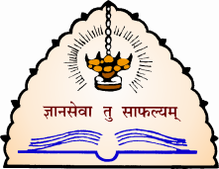



Government of Maharashtra

School Education and Sports Department

State Council of Educational Research & Training, Maharashtra

**708, Sadashiv Peth, Kumthekar Road, Pune 411030**

Telephone (020) 2447 6938 E-mail: [positionpapers@maa.ac.in](mailto:positionpapers@maa.ac.in)

**------------------------------------------------------------------------------------------------------------------------------------**

**Procedure to give your contribution for Position Papers for**

**New Education Policy 2020**

<https://scertmaha.ac.in/positionpapers/>

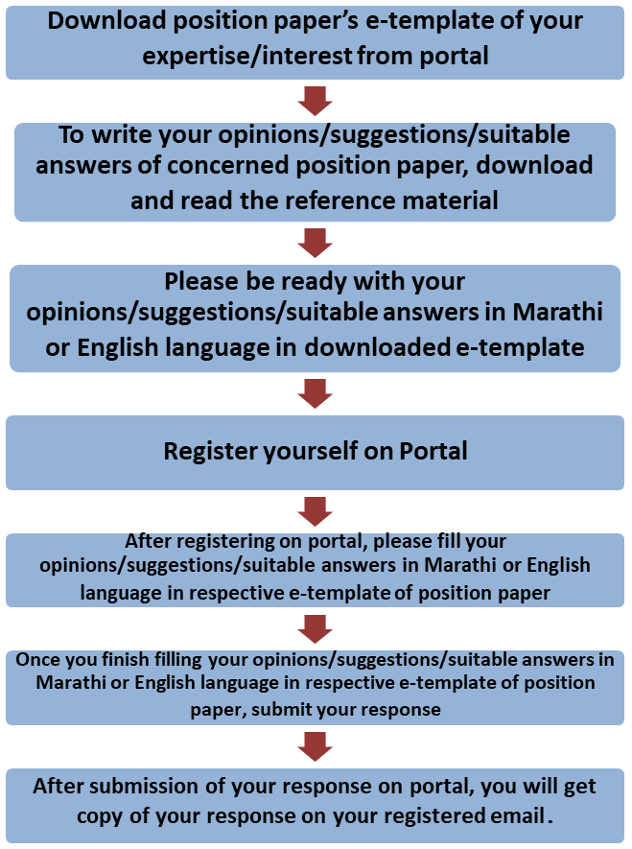

Last date of filling of your response is 30th May 2022

**Curriculum Development Department,**

**State Council of Educational Research and Training, Maharashtra, Pune**

# Philosophy of Education (Aims of Education)

**e-Template for the Position Paper of the Focus Group**

## Preliminary information

This section contains preliminary information regarding the focus group.

* 1. **Executive Summary/ Abstract** (0-500 words)

1. Introduction
   1. **Introduction to Philosophy of Education (***What is the present understanding on Philosophy of Education at the State or the National Level?* (0-300 words)
   2. **National Education Policy 2020 and Philosophy of Education (***Please respond to the NEP points on the purpose, aims, and vision, of education, including any suggestions you may have regarding additions or modifications-#1)* (0-300 words)
   3. **Current Challenges (***What aims of education are currently not being achieved? How will the new curriculum address these problems? #3*) (0-300 words)
   4. **Addressing Current Challenges** *(How can these aims be rooted in the Indian context and heritage while addressing the modern-day needs of the individual and of Indian and global society? What are the broad principles and approaches required to achieve these aims? #2)* (0-300 words)

## A paradigm shift in Philosophy of Education: Cross-Cutting themes

* 1. **Holistic Development of Learners** (*How can education be made more holistic by addressing not just cognitive goals, but also socio-emotional and ethical development of students? #4?*) (0-500 words)
  2. **New approaches of learning** (*The NEP suggests a shift from an expansive content focus to a focus on analytical thinking, problem-solving, and discussion. Which aims of education can be achieved through such a paradigm shift? What measures can be taken in school curriculum and pedagogy towards achieving this goal? #5)* (0-300 words)
  3. **Multidisciplinary and Interdisciplinary Experiences** (*Multidisciplinarity and removing*

“hard separations” are key policy thrusts of NEP 2020. Which aims of education can

be achieved through such a paradigm shift, and what measures can be taken in school curriculum and pedagogy towards achieving this goal? #6) (0-500 words)

* 1. **Increasing flexibility and choices for students *(****Another key policy thrust is flexibility for students to choose their learning pathways, especially in the Secondary Stage. How can the culture of the education system incorporate this paradigm shift, and what changes are needed to achieve it? #7)*(0-500 words)
  2. **Integrating Indian Knowledge Systems (***How should Indian knowledge systems, heritage, and traditions be incorporated into the education system, and what would be the benefits to overall learning? #*10) (0-500 words)
  3. **Developing Ethics and Moral values** *(How can the education system incorporate respect for diversity, respect for national spirit, and respect for local context, and what would be the benefits to overall learning?#8*) (0-500 words)

## **Multilingual Perspective** (Given the linguistic diversity of India and the benefits of multilingual education, how can the education system effectively incorporate multilingual education to enhance overall learning? #9) (0 -300 words)

1. Development Stages (5+3+3+4) and Science Curriculum

**(**The 4-stage design of Foundational (ages 3-8), Preparatory (ages 8-11), Middle (ages 11- 14), Secondary (ages 14-18) is critical for realizing the vision of NEP 2020.)

* 1. **Stage Specific Aims of Education**

(*Keeping the above questions in mind, please provide stage-specific aims of education for the Foundational, Preparatory, Middle and Secondary Stages.)* (0 -300 words)

## Foundational stage (0-200 words)

* + 1. Preparatory stage (0-200 words)
    2. Middle stage (0-200 words)
    3. Secondary stage
       1. Classes IX and X (0-200 words)
       2. Class XI and XII (0-200 words)

1. Specific Recommendations for National/State Curriculum Frameworks

(What are your specific recommendations for four curriculum frameworks with regard to philosophy of education?) (0-300 words)

## Specific recommendation for NCF/SCF ECCE (0-200 words)

* 1. Specific recommendation for NCF/SCF SE (0-200 words)
  2. Specific recommendation for NCF/SCF TR (0-200 words)
  3. Specific recommendation for NCF/SCF AE (0-200 words)

1. Any other comments and suggestions on this theme

(In this subsection, please provide other suggestions about the philosophy and aims of education that are not covered in the above questions. It is recommended that these suggestions are in alignment with the vision and specific anchors provided above from the NEP 2020.) (0 -300 words)

## Bibliography and References

*(Please include references (research papers, studies, pilots, or anecdotal evidence) throughout to help substantiate recommendations wherever applicable. A bibliography would also be most helpful for easy reference.)* (0 -500 words)

(Here, the system will allow the user to insert references in the APA format while filling up the document and will collate all the references in this section.)

## Filled by system Annexures

(Not mandatory. Please put in a title for an annexure along with a one- line description)