



Government of Maharashtra

School Education and Sports Department

State Council of Educational Research & Training, Maharashtra

**708, Sadashiv Peth, Kumthekar Road, Pune 411030**

Telephone (020) 2447 6938 E-mail: [positionpapers@maa.ac.in](mailto:positionpapers@maa.ac.in)

**------------------------------------------------------------------------------------------------------------------------------------**

**Procedure to give your contribution for Position Papers for**

**New Education Policy 2020**

<https://scertmaha.ac.in/positionpapers/>

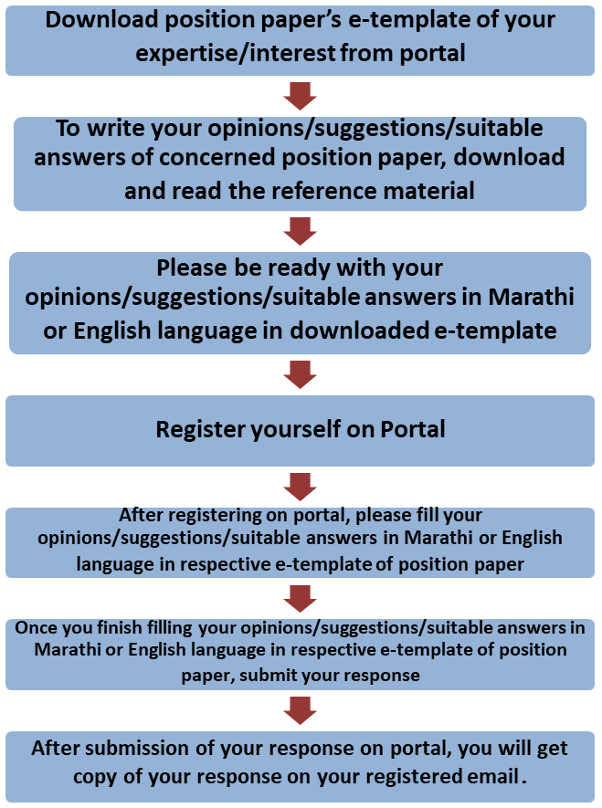

Last date of filling of your response is 30th May 2022

**Curriculum Development Department,**

**State Council of Educational Research and Training, Maharashtra, Pune**

## Publication of Quality Textual and Non-textual Materials: Issues, Challenge and Way Forward e- Template for Position Paper of the Focus Group

1. Preliminary information

This section contains preliminary information regarding the focus group.

* 1. **Executive Summary/Abstract** (1-500 words)

1. Introduction
   1. **Introduction to Quality Textual and Non-textual Materials** (*What is the present status/position regarding Publication of Quality Textual and Non-textual Materials? This also needs to include a brief on historical perspective and prevailing practices at the National or State or UT level.)* (1-500 words)
   2. **National Education Policy 2020 and Quality Textual and Non-textual Materials (***Please respond to the NEP 2020 points above on publication of quality textual and non-textual Materials for school education, including any suggestions you may have regarding additions or modification #1)* (1-500 words)*.*
   3. **Current Challenges *(****What are the problems currently faced related to textual and non- textual materials that must be addressed? #2)* (1-500 words)*.*
   4. **Addressing Current Challenges** *(How can we ensure that the problems listed in 2.3 are addressed/overcome? What is currently being done well in publication of quality textual and non-textual materials, and how can these present good practices/innovations/initiatives be strengthened/ scaled up? #3 and #4)* (1-300 words)

# Publication of Quality Textual and Non-textual Materials: Cross Cutting Concerns

* 1. **Criteria for Selection of Textual and Non-textual Materials** *(How will materials be sourced? Which criteria will inform selection of materials? How will the authenticity and validity of materials be ascertained? #5)* (1-500 words)*.*
  2. **Process of Developing Materials** *(What will be the process of developing materials? What kinds of challenges will arise while developing materials? What quality parameters need to be kept in mind while developing materials? #6)* (1-500 words)*.*
  3. **Connecting Textual and Non-textual Materials to the Local culture and context *(****Why is it important to develop materials that are connected to the local culture and context? #7)* (1-500 words)*.*
  4. **Involving Local Artists and Crafts People in Developing the Learning Materials** *(What kinds of materials will be required for music and art education? Can local artists and craftspeople be involved in developing these materials? Will students be able to participate in developing materials during the duration of these courses? #14)* (1-500 words)*.*
  5. **Inclusion of Children from SEDGs** *(How can equity and inclusion be incorporated in materials, particularly with respect to children from socio-economically disadvantaged groups (SEDGs)? What considerations will inform materials that inculcate sensitivity and respect for diversity? How can aspects of different cultures be included in the materials? How can materials be free of bias and stereotypes – what are expectations from material developers in this aspect? What criteria will be used to evaluate materials? What considerations will inform the development of materials for children with disabilities? How will they be used by students and teachers? What criteria will be used for ensuring equivalence of materials? #8 and #18*) (1-500 words)*.*
  6. **Redesigning Learning Materials for Reorienting Learning** *(With the aim of reorienting learning, how textbooks and other learning materials should be redesigned? What parameters will be used to define quality? #11)* (1-300 words)*.*
  7. **Developing Supplementary Enrichment Materials** *(How can workbooks be used – for learning, for assessment, or for both? What would need to be kept in mind when designing workbooks? What criteria will be used to define supplementary enrichment materials? Who will these materials are meant for? Who will develop them? How will they be used? #9 and #19)* (1-500 words)*.*
  8. **Quality Textual and Non-textual Materials and Multilingual Perspective *(****What considerations will inform the development of bilingual materials? How will they be used by students and teachers? What criteria will be used for ensuring equivalence of materials? How will materials be developed in various languages? Will translation be required? What kind of mechanisms would be required to enable this? How can sign language be included among the other languages in school? What considerations will inform this inclusion? #12, #13 and #17)* (1-600 words)*.*
  9. **Educational Technology for Developing Quality Textual and Non-textual Materials** *(What infrastructure, devices, connectivity and support will enable the use of technology? What kind of learner and teacher preparedness is required? How will technology-based materials be developed? What will be the criteria to determine the quality of technology- based materials? What role should DIKSHA play? What can be done to improve DIKSHA further? What kinds of technology can be used to enhance textbook development? #16, #10 and #26)* (1-500 words)*.*
  10. **Reducing the Content of Textbooks** *(What should be the approach to textbooks (e.g., interactive, cross-disciplinary references, contextual, etc.)? What would be the criteria for selecting essential core content and supplementary content? What can be done to reduce the content of textbooks and thereby the weight of the school bag? #20)* (1-500 words)*.*
  11. **Variety of Textual and Non-Textual Material***(How will a set of textbooks (i.e., more than one textbook) be made available to teachers? How can they be supported to choose which*

they prefer to use? What material other than textbooks can teachers choose to use? #21)

## (1-300 words)*.*

* 1. **Preparing Low Costs Textbooks** *(How can textbooks be prepared at low costs while retaining quality? What criteria should be used to assess textbooks for quality? Please illustrate with examples, where possible. #22)* (1-600 words)*.*
  2. **Contextualising Textbooks** *(How can textbooks be given a ‘State flavor’? How can such textbooks be used to ensure quality learning? What should be the process of textbook development (principles to inform choosing teams, selecting content, layout and design, printing, etc). Which subjects will need a new set of textbooks? What kind of contextualisation will be required? #23 and #24? )* (1-600 words)*.*

1. **Developmental Stages (5+3+3+4) and Science Curriculum *(****The 4-stage design of Foundational (ages 3-8), Preparatory (ages 8-11), Middle (ages 11-14), Secondary (ages 14-18) is critical for realizing the vision of NEP 2020. In this section, please give specific proposals and illustrations for the 4 stages of this curricular area*). (1-300 words)*.*
   1. **Publication of Quality Textual and Non-textual Materials to achieve Core Learning Objectives** *(What kind of materials would need to be developed for different stages to achieve the goals of the Policy? What kinds of games, puzzles, activities, etc can be used at different school stages to develop relevant capacities? Please illustrate with suitable examples. #27)*

## Foundational stage (1 -400 words)

* + 1. Preparatory stage (1 -400 words)
    2. Middle stage (1 -400 words)
    3. Secondary stage
       1. Classes IX and X (1 -400 words)
       2. Classes XI and XII (1 -400 words)
  1. **Materials to Develop Digital Literacy** *(What kind of materials will be required to develop digital literacy at different school stages? What considerations for safety and security will need to be kept in mind? #15 and 28)*
     1. Foundational stage (1 -200 words)
     2. Preparatory stage (1 -200 words)
     3. Middle stage (1 -200 words)
     4. Secondary stage
        1. Classes IX and X (1 -200 words)

## Classes XI and XII (1 -200 words)

1. **Enabling Conditions for Publication of Quality Textual and Non-textual Materials (***What enabling conditions (e.g., school culture, practices,infrastructure, equipment, governance, etc.) should be in place in order to effectively enable all the above transformations? #25*) (1 -200 words)

## School Culture and Practices (1 -200 words)

* 1. Infrastructure and Equipment (1 -200 words)
  2. Human Resource – Teaching as well as supporting (1 -200 words)
  3. Technology related (1 -200 words)
  4. School Governance (1 -200 words)
  5. School Complex (1 -200 words)
  6. Any other (1-200 words)

1. **Specific Recommendations for the National/State Curriculum Frameworks** *(What are your specific recommendations for four curriculum frameworks with regard to Publication of Quality Textual and Non-textual Materials?)* (1-300 words)

## Specific recommendations for NCF/SCF ECCE (1 -200 words)

* 1. Specific recommendations for NCF/SCF SE (1 -200 words)
  2. Specific recommendations for NCF/SCF TE (1 -200 words)
  3. Specific recommendations for NCF/SCF AE (1 -200 words)

1. **Any other Comments and Suggestions on this Theme** (*In this subsection, please provide other suggestions about Publication of Quality Textual and Non-textual Materials that are not covered in the above questions. It is recommended that these suggestions are in alignment with the vision and specific anchors provided above from the NEP 2020*). (1 - 300 words)

# Bibliography and References

**(**Please include references (research papers, studies, pilots, or anecdotal evidence) throughout to help substantiate recommendationswherever applicable. A bibliography would also be most helpful for easy reference.**)**

***(Here, the system will allow the user to insert references in the APA format while filling up the document and will collate all the references in this section.)***

## Filled by system.

Annexures

(Not mandatory. Please put in a title for an annexure along with a one- line description)