



Government of Maharashtra

School Education and Sports Department

State Council of Educational Research & Training, Maharashtra

**708, Sadashiv Peth, Kumthekar Road, Pune 411030**

Telephone (020) 2447 6938 E-mail: [positionpapers@maa.ac.in](mailto:positionpapers@maa.ac.in)

**------------------------------------------------------------------------------------------------------------------------------------**

**Procedure to give your contribution for Position Papers for**

**New Education Policy 2020**

<https://scertmaha.ac.in/positionpapers/>

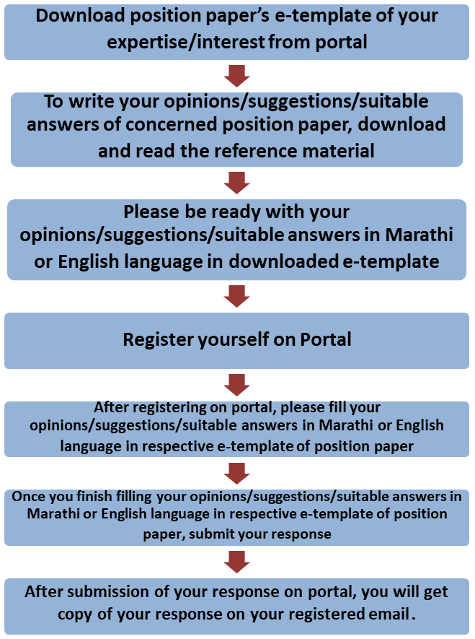

Last date of filling of your response is 30th May 2022

**Curriculum Development Department,**

**State Council of Educational Research and Training, Maharashtra, Pune**

# Reform in Examinations and Holistic Progress Card e-Template for the Position Paper of the Focus Group

1. **Preliminary information**

This section contains preliminary information regarding the focus group.

* 1. **Executive Summary/Abstract** (0-500 words)

1. **Introduction**
   1. **Introduction to Examination Reforms**

(What is the present status/position of assessment / Examination system? This also needs to include a brief on historical perspective and prevailing practices at the National or State or UT level) (0-300 words)

# National Education Policy 2020 and Reform in Examinations and Holistic Progress Card

**(**Please respond to the NEP 2020 points on Reform in assessment and Holistic Progress Card, including any suggestions you may have regarding additions or modification-#1) (0-300 words)

# Current Challenges

**(**What are the problems currently faced in assessment / examinations, including Board Examinations? #2) (0-300 words)

# Addressing Current Challenges

## (How can we ensure that the problems listed in 2.3 are addressed/overcome? What is currently being done well in *assessments and examinations,* and how can these present good practices/innovations/initiatives be strengthened/ scaled up? *#3 and #4*) (0-300 words)

1. **Reform in Examinations and Holistic Progress Card: Cross Cutting themes**
   1. **Moving towards “Assessment for Learning” from “Assessment of Learning”**

(How can the shift to “assessment for learning” be made? How can core concepts and skills be identified? What will be the approach to assessment of these core capacities and skills? How will higher order capacities be assessed? Please illustrate how assessment will be used for learning. How can assessment be made rigorous, valid, ethical and fair? #5 and #11) (0-500 words)

# Setting Standards in School Education

(What is meant by competency-based learning? How can standards support competency-based learning? What is the relevance of standards in school education, what should these standards be, and how should they be set? What is the relationship between standards and competence? What is the relationship between standards and learning outcomes? How can standards help in ensuring equivalence across school boards? Why is this important for meeting the goals of NEP 2020? #7, #6, and #8) (0-500 words)

# Reforms in Board Examinations

**(**How can the transition to the reformed Board examinations be made? How can the high stakes nature of examinations be changed? How can Board examinations be offered in a flexible manner, and what are the implications for content, frequency and reporting of examinations? What changes will be required in the school curriculum and processes to make this possible? What is meant by modular Board examinations, what are the advantages of such modular Board exams, and how could they be carried out in practice in India? How can subjects be offered at two levels without compromising on the essential subjects, concepts and skills mentioned in the NEP 2020? #9**)** (0-500 words)

# Teacher Capacity Building for Implementing Reform in Examinations and Holistic Progress Card in Schools

**(**How can schools and teachers be supported to implement formative assessments? What kind of resources can be provided to them, who will develop them, and how can orientation and feedback be facilitated? How can teachers have autonomy to take decisions related to assessment? Please illustrate how assessment tools can be developed and used. #10**)** (0-600 words)

* 1. **Assessment for Systemic Improvement** *(What is the need for systemic assessments in classes 3, 5 and 8? How are these different from regular school examinations? How can the results of large-scale assessments be used to improve educational processes and outcomes? How can they be used for developmental purposes? At what frequency should they be held? What should be the approach, and how can the process be made manageable without compromising on rigor and results? How can confidentiality be maintained? How should results be reported? How can these assessments be used for systemic improvement? #12)* (0-600 words)
  2. **Using Technology in Assessment *(****What are the advantages and challenges of using technology in assessment? What is meant by adaptive assessments? How can they be used to support student learning? Please outline a roadmap with relevant transitions for using technology for assessment. #13****)*** (0-500 words)

# Multidimensional Assessment

**(**What will be the contours of a holistic progress card? What is meant by a 360- degree, multidimensional report – what will it contain and who will be involved in reporting progress? What is its relevance? How will records be maintained and reporting done?#14**)** (0-500 words)

# Roles of Various Agencies for bringing Reform in Assessment, Examination and Testing for Reducing Stress on Students

**(**What should be the expectations from PARAKH? How will the NTA enable reduction of stress and burden on students? How can universities and employers use the results of NTA tests? What should be the nature of NTA tests? How can they ensure equivalence across Boards? #18 and #15**)** (0-500 words)

# Approach to assessment across Developmental Stages (5+3+3+4)

**(**The 4-stage design of Foundational (ages 3-8), Preparatory (ages 8-11), Middle (ages 11-14), Secondary (ages 14-18) is critical for realizing the vision of NEP 2020. What is the approach to assessment in each of the four stages? How is this approach appropriate for each relevant stage? How would the assessment/examination have fidelity to the learning objectives set in the curriculum? #16, #17). (0-200 words)

## Foundational stage (0 -200 words)

* + 1. Preparatory stage (0 -200 words)
    2. Middle stage (0 -200 words)
    3. Secondary stage
       1. Classes IX and X (0 -200 words)
       2. Classes XI and XII (0 -200 words)

1. **Specific Recommendations for the National/State Curriculum Frameworks** *(What are your specific recommendations for four curriculum frameworks with regard to Reform in Examinations and Holistic Progress Card?)*(0-300 words)

## Specific recommendations for NCF/SCF ECCE(0 -200 words)

* 1. Specific recommendations for NCF/SCF SE (0 -200 words)
  2. Specific recommendations for NCF/SCF TE (0 -200 words)
  3. Specific recommendations for NCF/SCF AE (0 -200 words)

1. **Any other comments and suggestions on this theme** (*In this subsection, please provide other suggestions about Reform in Examinations and Holistic Progress Card that are not covered in the above questions. It is recommended that these suggestions are in alignment with the vision and specific anchors provided above from the NEP 2020*). (0 - 200 words)

# Bibliography and References

**(**Please include references (research papers, studies, pilots, or anecdotal evidence) throughout to help substantiate recommendations wherever applicable. A bibliography would also be most helpful for easy reference.**)**(0 -500 words)

***(Here, the system will allow the user to insert references in the APA format while filling up the document and will collate all the references in this section.)***

## Filled by system.

Annexures

(Not mandatory. Please put in a title for an annexure along with a one-line description)