



Government of Maharashtra

School Education and Sports Department

State Council of Educational Research & Training, Maharashtra

**708, Sadashiv Peth, Kumthekar Road, Pune 411030**

Telephone (020) 2447 6938 E-mail: [positionpapers@maa.ac.in](mailto:positionpapers@maa.ac.in)

**------------------------------------------------------------------------------------------------------------------------------------**

**Procedure to give your contribution for Position Papers for**

**New Education Policy 2020**

<https://scertmaha.ac.in/positionpapers/>

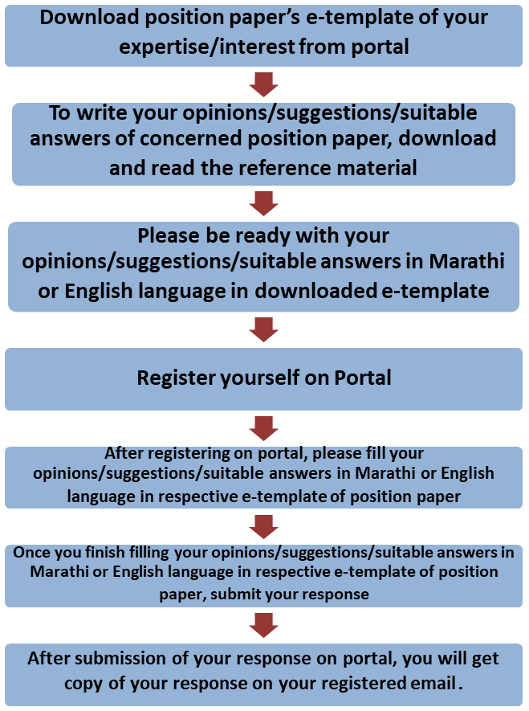

Last date of filling of your response is 30th May 2022

**Curriculum Development Department,**

**State Council of Educational Research and Training, Maharashtra, Pune**

# School Governance and Leadership

**e-Template for Position Paper of the Focus Group**

1. **Preliminary information**

This section contains preliminary information regarding the focus group.

* 1. **Executive Summary/Abstract** (1-500 words)

1. **Introduction**
   1. **Introduction to School Governance and Leadership** *(What is the present status/position regarding School Governance and Leadership? This also needs to include a brief on historical perspective and prevailing practices at the National or State or UT level)* (1-300 words)
   2. **National Education Policy 2020 and School Governance and Leadership** *(Please respond to the NEP 2020 points on School Governance and Leadership, including any suggestions you may have regarding additions or modification. #1)* (1-300 words)
   3. **Current Challenges** *(What are the problems currently faced in the School Governance and Leadership that must be addressed? #2)* (1-500 words)
   4. **Addressing Current Challenges** *(How can we ensure that the problems listed in 2.3 are addressed/overcome? What is currently being done well in School Governance and Leadership, and how can these present good practices/innovations/initiatives be strengthened/scaled up? #3 and #4)* (1-500 words)
2. **Criteria for Grouping Schools into Complexes** (*What should be the criteria for grouping schools into a complex? What considerations will inform the geographic area a school complex should cover? How can schools within a complex be accessible for all students (especially girls, young children and other vulnerable groups? #*5)(1-100 words)
3. ***Infrastructural Requirement and Learning Resources*** *(What kind of infrastructure and learning resources should be available in each school within a school complex? How will schools in the complex work out a method for sharing resources? How will teachers and students be given access to use these resources? What kinds of systems will be required to facilitate the movement of equipment and students within the school complex? #6) (1-500 words)*
4. **Leadership in Schools** *(What kind of leadership is desirable for schools to run efficiently and smoothly? What kind of capacities and support systems would the head of the school complex require? How can the leader involve the entire set of teachers and staff to function as a team? #7)* (1-500 words) .
5. **School Complex and Vibrant Teacher Community** (*How will the school complex build a vibrant teacher community? How will teachers work together to achieve the purpose of the school complex? #8)* (1-300 words) *.*
6. **Support System for School Complex (***How will the recruitment and sharing of social workers and counsellors be implemented on ground? What are potential bottlenecks that the school complex may encounter and measures that would need to be taken to be able to adequately support all students that the school complex serves? #9)* (1-500 words) .
7. **School Complex Management Committee** *(Who should be eligible to become a member of the School Complex Management Committee? What kind of support/training would SCMCs require to be fully functional? What would the relationship be between a SCMC and a school leader? What should the SCMC be responsible for in terms of school and classroom processes?#10)* (1-500 words)
8. **Enabling Conditions for School Governance and Leadership** (*What other enabling conditions (e.g., school culture, practices, infrastructure, equipment, governance, etc.) should be in place in order to effectively enable all the above transformations? #*11) (1-300 words) .
9. **Stage-wise Requirements for School Governance and Leadership** (*What are the requirements at each stage for School Governance and Leadership, in terms of specific developmental characteristics and requirements of students, their parents, teachers, staff and stakeholders at each stage? #14)* (1-300 words)

## Foundational stage (1-200 words)

* 1. Preparatory stage (1-200 words)
  2. Middle stage (1-200 words)
  3. Secondary stage
     1. Classes IX and X (1-200 words)
     2. Classes XI and XII (1-200 words)

1. **Centrally Sponsored Schemes for Quality Improvement in Schools** *(How do Centrally Sponsored Schemes such as ‘Samagra Shiksha’ play a role in bringing quality improvement in schools, and how could they be further strengthened?? #12)* (1-300 words)
2. **Strengthening Linkages among Institutions at Different Levels** (How strong are the linkages among schools, BRCs, CRCs, DIETs, BITEs, and SCERT? What steps can be taken to further strengthen these linkages for implementing the NEP 2020 and the new NCF/SCFs? #13) (1-300 words)
3. **Specific Recommendations for the National/State Curriculum Frameworks** *(What are your specific recommendations for four curriculum frameworks with regard to School Governance and Leadership?)* (1-300 words)

## Specific recommendations for NCF/SCF ECCE (1-200 words)

* 1. Specific recommendations for NCF/SCF SE (1-200 words)
  2. Specific recommendations for NCF/SCF TE (1-200 words)
  3. Specific recommendations for NCF/SCF AE (1-200 words)

1. **Any other Comments and Suggestions on this Theme** *(In this subsection, please provide other suggestions about School Governance and Leadership that are not covered in the above questions. It is recommended that these suggestions are in alignment with the vision and specific anchors provided above from the NEP 2020)* (1-200 words)

# Bibliography and References

(Please include references (research papers, studies, pilots, or anecdotal evidence) throughout to help substantiate recommendationswherever applicable. A bibliography would also be most helpful foreasy reference.)

(Here, the system will allow the user to insert references in the APA format while filling up the document and will collate all the references in this section.)

## Filled by system.

Annexures

(Not mandatory. Please put in a title for an annexure along with a one- line description)