



Government of Maharashtra

School Education and Sports Department

State Council of Educational Research & Training, Maharashtra

**708, Sadashiv Peth, Kumthekar Road, Pune 411030**

Telephone (020) 2447 6938 E-mail: [positionpapers@maa.ac.in](mailto:positionpapers@maa.ac.in)

**------------------------------------------------------------------------------------------------------------------------------------**

**Procedure to give your contribution for Position Papers for**

**New Education Policy 2020**

<https://scertmaha.ac.in/positionpapers/>

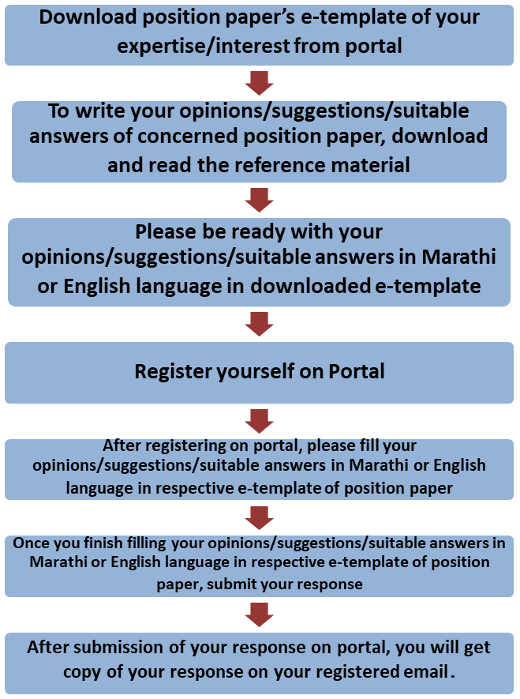

Last date of filling of your response is 30th May 2022

**Curriculum Development Department,**

**State Council of Educational Research and Training, Maharashtra, Pune**

# Teacher Education

**e-Template for Position Paper of the Focus Group**

1. **Preliminary information**

This section contains preliminary information regarding the focus group.

* 1. **Executive Summary/Abstract** (1-500 words)

1. **Introduction**
   1. **Introduction to Teacher Education** *(What is the present status/position regarding Teacher Education? This also needs to include a brief on historical perspective and prevailing practices at the National or State or UT level.)* (1-300 words)
   2. **National Education Policy 2020 and Teacher Education** *(Please respond to the NEP 2020 points on Teacher Education, including any suggestions you may have regarding additions or modification. #1)* (1-300 words)
   3. **Current Challenges** *(What are the current challenges in Teacher Education, both pre- service and in-service? #2)* (1-500 words)
   4. **Addressing Current Challenges** *(How can we ensure the challenges outlined in 2.3 are addressed/overcome in the next five years? What are the existing mechanisms that would need to be strengthened to make this a reality? What new mechanisms would need to be put in place? #3)* (1-500 words)
2. **Transforming Pre-service Teacher Education *(****NEP 2020 envisages a complete transformation of pre-service teacher education with the four-year programme in multidisciplinary institutions. What would be the approach to establishing and running the four-year programme over the next five years so that it becomes the primary qualification to become a teacher? Which set of multidisciplinary institutions could offer this programme within the next three years? What kind of support would these institutions need for this to happen? #4 and #5*) (1-300 words)
3. **Linkage between Teacher Education and School Education** *(What are the coordination mechanisms envisaged between higher education and school education to ensure that there is a continuous link between teacher education programs and the school system? #6)* (1-300 words)

# Stage-wise Requirements for Teacher Education Programme

* 1. **Core Principles and Broad Design of Teacher Education Programme** *(What are the core principles and broad design of the four-year dual-degree teacher education programme? What would be the linkages and the distinctions between programmes preparing teachers for each of the following stages: #12)* (1-300 words)

## Foundational stage (1-200 words)

* + 1. Preparatory stage (1-200 words)
    2. Middle stage (1-200 words)
    3. Secondary stage
       1. Classes IX and X (1-200 words)
       2. Classes XI and XII (1-200 words)
  1. **Curriculum, Pedagogy and School Experience for Teacher Education Programme** *(What would be the broad curriculum, pedagogy, and school experience required to develop teachers specialized in each of the school stages along with a school subject? # 13)* (1-500 words)

## Foundational stage (1-200 words)

* + 1. Preparatory stage (1-200 words)
    2. Middle stage (1-200 words)
    3. Secondary stage
       1. Classes IX and X (1-200 words)
       2. Classes XI and XII (1-200 words)

1. **Transformation in Schooling System and its Implications for Teacher Education** *(NEP 2020 envisages several key transformations - focus on and integration of early childhood education, achieving foundational literacy and numeracy, restructuring of School Stages, and commensurate changes in the curriculum, pedagogy, assessment, and materials across Stages through the new NCF and SCF. These transitions require careful and detailed planning for implementation, close review of impact on the ground as well as mid-course corrections. They also demand significant and continuous academic and administrative support for teachers. What would be the role of all stakeholders, including SCERT, DIETs, BRCs and CRCs to support these transformations as envisaged in NEP 2020? #7)* (1-500 words)
2. **Rejuvenation of Teacher Education Institutions (***What would be the approach to planning rejuvenation of the SCERT, DIETs, BRCs and CRCs towards this transformation as discussed in point no. 6?* #8) (1-500 words)
3. Teacher Continuous Professional Development (*What would be the approach to and design of in-service teacher education that will address these requirements? How would it be ensured*

that continuous professional development programmes designed as envisaged in NEP 2020 are available to all teachers? #9 & #10) (1-500 words)

1. **Enabling Conditions for Teacher Education** *(What other enabling conditions (e.g., culture of teacher education institutes, practices, infrastructure, equipment, governance, etc.) should be in place to effectively enable all the above transformations? #11)* (1-300 words)
2. **Specific Recommendations for the National/State Curriculum Frameworks** *(What are your specific recommendations for four curriculum frameworks regarding Teacher Education?)* (1-300 words)

## Specific recommendations for NCF/SCF ECCE (1-200 words)

* 1. Specific recommendations for NCF/SCF SE (1-200 words)
  2. Specific recommendations for NCF/SCF TE (1-200 words)
  3. Specific recommendations for NCF/SCF AE (1-200 words)

1. **Any other Comments and Suggestions on this Theme** *(In this subsection, please provide other suggestions about Teacher Education that are not covered in the above questions. It is recommended that these suggestions are in alignment with the vision and specific anchors provided above from the NEP 2020).* (1-200 words)

# Bibliography and References

(Please include references (research papers, studies, pilots, or anecdotal evidence) throughout to help substantiate recommendationswherever applicable. A bibliography would also be most helpful for easy reference.)

(Here, the system will allow the user to insert references in the APA format while filling up the document and will collate all the references in this section.)

## Filled by system.

Annexures

(Not mandatory. Please put in a title for an annexure along with a one- line description)