



Government of Maharashtra

School Education and Sports Department

State Council of Educational Research & Training, Maharashtra

**708, Sadashiv Peth, Kumthekar Road, Pune 411030**

Telephone (020) 2447 6938 E-mail: [positionpapers@maa.ac.in](mailto:positionpapers@maa.ac.in)

**------------------------------------------------------------------------------------------------------------------------------------**

**Procedure to give your contribution for Position Papers for**

**New Education Policy 2020**

<https://scertmaha.ac.in/positionpapers/>

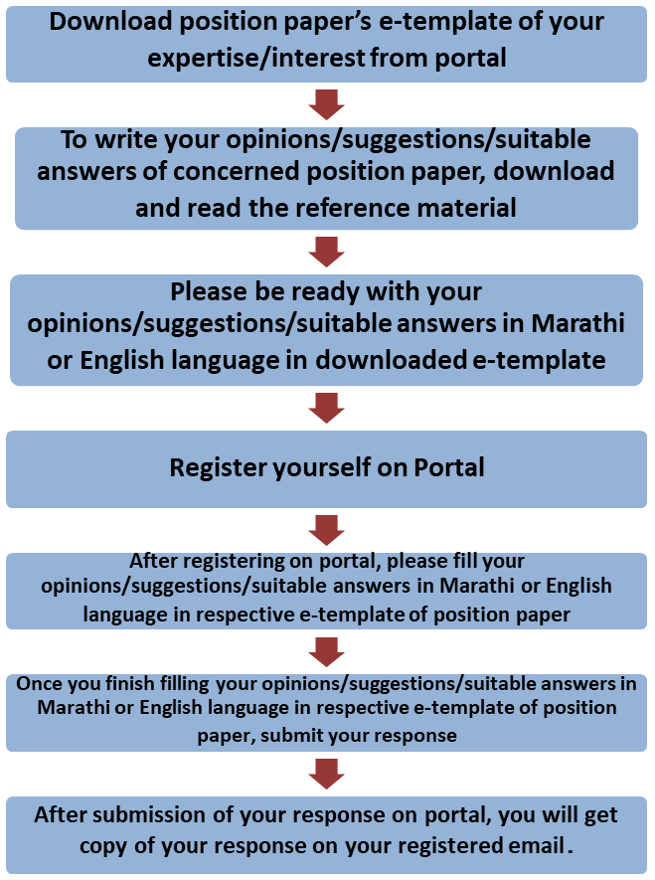

Last date of filling of your response is 30th May 2022

**Curriculum Development Department,**

**State Council of Educational Research and Training, Maharashtra, Pune**

# Technology in Education

**e-Template for Position Paper of the Focus Group**

1. **Preliminary information**

This section contains preliminary information regarding the focus group.

* 1. **Executive Summary/Abstract** (1-500 words)

1. **Introduction**
   1. **Introduction to Technology in Education** *(What is the present status/position regarding Education Technology? This also needs to include a brief on historical perspective and prevailing practices at the National or State or UT level. #2)* (1-300 words)
   2. **National Education Policy 2020 and Technology for School Education***(Please respond to the NEP 2020 points on Education Technology for school education, including any suggestions you may have regarding additions or modification. #1)* (1- 300 words)
   3. **Addressing Current Challenges** *(The aim of “appropriate use” and “integration of technology at all levels” in education is to achieve the policy objectives of quality, inclusive, equitable and lifelong learning. How can the advantages and opportunities of technology be reaped to make India a “knowledge superpower” while minimizing the downsides and associated risks, including issues related to the digital divide and data-related issues of misuse, privacy and security? What are the possible approaches for “bridging the digital divide”, so as to fully leverage the digital dividend? #4 and #10)* (1-500 words)

# Technology in Education: Integration across Curriculum and Pedagogy

* 1. **Role of Technology in Education** *(What should be the role of technology to support learners, teachers, parents and administrators? What is the nature of the “bi- directional” relationship and influence between education and technology? What is its impact across the four areas of NCF - Early Childhood education, school education, teacher education, and adult education? #2)* (1-300 words)
  2. **Integration of Technology in Education *(****How can technology be integrated into the areas mentioned below? #3)*
     1. Education processes: (*Teaching, learning and evaluation processes* )(1-200 words)
     2. Administrative processes: (*Streamlining educational planning, processes related to admissions, attendance, assessments, teacher requirement planning forecasting)* (1-200 words)
     3. Teacher Education: (*Supporting teacher preparation and professional development, including standardised training at large scale in a short period of time and in B.Ed. programs)* (1-200 words)
     4. Access: (*Enhancing educational access to those from remote areas and disadvantaged backgrounds)* (1-200 words)
     5. Support to *Divyang* Students: (*Assistance and appropriate support to Divyang students, support to teachers to detect and plan mitigations for specific disabilities, solutions for their parents and care-givers along with wide scale dissemination of learning materials)* (1-200 words)
     6. Adult Learning*: (Quality technology based options for adult learning)*(1-200 words)
     7. Language Learning and Removing Language Barriers: *(Removing language barriers to learning, language translations, popularising learning of languages, multilingual education, language preservation and promotion, extensive participation of people through crowd sourcing)* (1-200 words)

## Textbook Development and Textbook Review Processes (1-200 words)

* + 1. Examination Process (1-200 words)
    2. Other: *Are there any other areas where technology could be used?* (1-200 words)
  1. **Reconfiguring Digital-enabled Pedagogies** *(What should be the role of technology to support learners, teachers, parents and administrators? What is the nature of the “bi- directional” relationship and influence between education and technology? What is its impact across the four areas of NCF - Early Childhood education, school education, teacher education, and adult education? NEP calls for “reconfiguring” pedagogical structures to make it “responsive and relevant” - what should be the considerations for reconfiguring digital-enabled pedagogies, while keeping in mind the potential benefits and risks? Can technology related to gamification be used effectively for curriculum transaction? How? #9 and #11)* (1-500 words)
  2. **Developing Competencies and Skills** *(What are the competencies and Skills related to technology in education? How should competencies and skills related to technology in education be developed in children, teachers and adult learners across the stages? What changes in the curriculum would be required to achieve this? #13)* (1-500 words)

1. **New Initiatives *(****“New circumstances and realities require new initiatives.” What are some notable examples and experiences, including benefits and downsides, from recent years, such as the current pandemic period responses, of how technology was used? From these examples, can guidelines or frameworks be created for appropriate use and integration of technology at all levels, including mitigating the downsides and risks? How would these guidelines differ across early childhood, school, teacher and adult education, and across various areas listed above in point 3? #5)* (1-500 words)
2. **Technology in Education for Future** *(Given the rapidly evolving nature of technology, and the emergence of disruptive technologies such as AI, how should we prepare for “the*

multiple ways in which technology will impact education, “only some of which can be foreseen at the present time”? # 6) (1-300 words)

1. **Effectiveness of Technology Use in Education** *(What are principles and mechanisms for evaluating the effectiveness of technology use in education? #7)* (1-300 words)
2. **Capacity Building of Teachers and Administrators *(****Any technology is a tool whose effectiveness also depends on the capabilities of the people who use it. What should be the approach towards building the capabilities of teachers, administrators etc. for using technology effectively?# 8)* (1-300 words)
3. **Enabling Conditions for using Technology in Education Effectively** *(What other enabling conditions (e.g., school culture, practices, infrastructure, equipment, governance,* community, *etc.) should be in place in order to effectively enable all the above transformations? #12) (*1-200 words)

## School Culture and Practices (1-200 words)

* + 1. Infrastructure and Equipment (1-200 words)
    2. Human Resource – Teaching as well as supporting (1-200 words)
    3. School Governance (1-200 words)
    4. School Complex (1-200 words)
    5. Community (1-200 words)
    6. Any other (1-200 words)

1. **Role of various Agencies for using Technology in Education for Schools** Education *(What roles, various agencies for example, SIETs, SCERTs, DIETs, CTEs, IASEs, NIEPA, NCERT, KVS, NVS, CBSE, School Education Boards, Universities, CSR initiatives, philanthropic organizations, NGO, SIEMAT, local administration etc., can play in enhancing the use of technology in Education for Schools Education?)* (1-400 words) (ECCE, SE, TE, AE)
2. **Specific Recommendations for the National/State Curriculum Frameworks** *(What are your specific recommendations for four curriculum frameworks with regard to Education technology?)* (1-300 words)

## Specific recommendations for NCF/SCF ECCE (1-200 words)

* 1. Specific recommendations for NCF/SCF SE (1-200 words)
  2. Specific recommendations for NCF/SCF TE (1-200 words)
  3. Specific recommendations for NCF/SCF AE (1-200 words)

1. **Any other Comment and Suggestion on this Theme** *(In this subsection, please provide other suggestions about Education technology that are not covered in the above questions. It is recommended that these suggestions are in alignment with the vision and specific anchors provided above from the NEP 2020).* (1-200 words)

# Bibliography and References

(Please include references (research papers, studies, pilots, or anecdotal evidence) throughout to help substantiate recommendationswherever applicable. A bibliography would also be most helpful for easy reference.)

(Here, the system will allow the user to insert references in the APA format while filling up the document and will collate all the references in this section.)

## Filled by system.

Annexures

(Not mandatory. Please put in a title for an annexure along with a one- line description)