



Government of Maharashtra

School Education and Sports Department

State Council of Educational Research & Training, Maharashtra

**708, Sadashiv Peth, Kumthekar Road, Pune 411030**

Telephone (020) 2447 6938 E-mail: [positionpapers@maa.ac.in](mailto:positionpapers@maa.ac.in)

**------------------------------------------------------------------------------------------------------------------------------------**

**Procedure to give your contribution for Position Papers for**

**New Education Policy 2020**

<https://scertmaha.ac.in/positionpapers/>

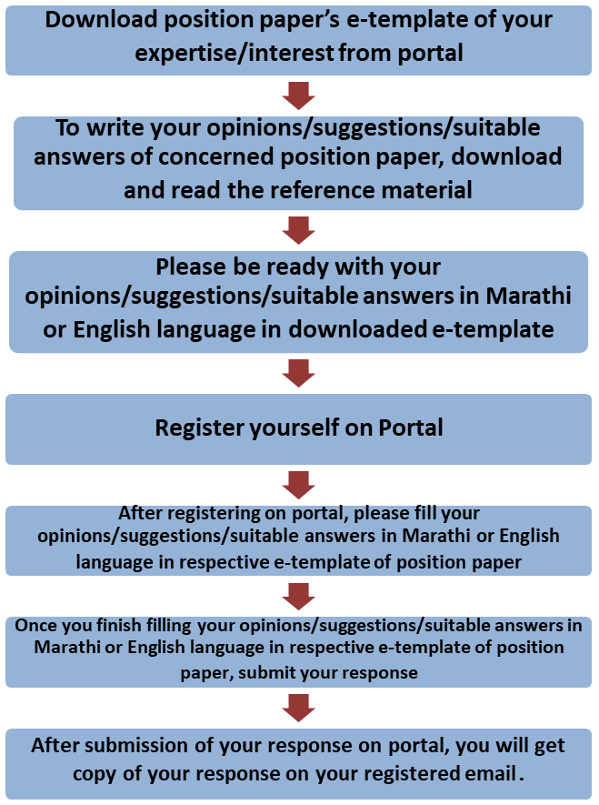

Last date of filling of your response is 30th May 2022

**Curriculum Development Department,**

**State Council of Educational Research and Training, Maharashtra, Pune**

# Value Education

**e-Template for Position Paper of the Focus Group**

1. **Preliminary information**

This section contains preliminary information regarding the focus group.

* 1. **Executive Summary/Abstract** (1-500 words)

1. **Introduction**
   1. **Introduction to Value Education** *(What is the present status/position regarding Value Education? This also needs to include a brief on historical perspective and prevailing practices at the National or State or UT level.)* (1-300 words)
   2. **National Education Policy 2020 and Value Education** *(Please respond to the NEP 2020 points on value education, including any suggestions you may have regarding additions or modification. #1)* (1-300 words)
   3. **Current Challenges** *(What are the problems currently faced in the curriculum and pedagogy of value education? #2)* (1-300 words)
   4. **Addressing Current Challenges** *(How can we ensure that the problems listed in 2.3 are addressed/overcome? What is currently being done well in value education, and how can these present good practices/innovations/initiatives be strengthened/scaled up? #3 and #4)* (1-300 words)

# Value Education as a Cross-cutting Area for Curriculum and Pedagogy

* 1. **Development of Values in Learners** *(What should be the approach in curriculum and pedagogy to develop the values of: compassion and empathy; patience and kindness; honesty and integrity; private and public hygiene; personal responsibility? Can case studies based on ethical dilemmas, and other such approaches, be integrated into the curriculum at various stages? How? #7 and #9)* (1-300 words)
  2. **Using Indian Knowledge Systems to Impart Values** *(In what ways can India’s literature, traditional values, culture, and ancient systems of ethics and philosophy be used to impart values in the modern world? #8)* (1-300 words)
  3. **Other Cross-cutting Concerns***(How would concerns about basic health and safety be addressed in the curriculum? What is the role of these concerns in other curricular areas such as physical education and science education? What should be the approach*

to sex education? How would sex education incorporate the values of consent, respect, safety and prevention of diseases? #5 and #6) (1-500 words)

# Developmental Stages (5+3+3+4) and Value Education

* 1. **Core Learning Objectives of Value Education** *(What are the core learning objectives and outcomes, i.e., key values, dispositions and capacities, that all students must develop related to value education by Grade 12? How should these capacities be developed across each stage (Foundational: up to 8yrs; Preparatory: 8-11yrs; Middle: 11-14yrs; High: 14-18yrs)? #10)* (1- 200 words)

## Foundational stage (1-200 words)

* + 1. Preparatory stage (1-200 words)
    2. Middle stage (1-200 words)
    3. Secondary stage
       1. Classes IX and X (1-200 words)
       2. Classes XI and XII (1-200 words)
  1. **Stagewise Progression of Development of Moral Reasoning and Ethical Values** *(What is the stagewise progression of development of moral reasoning and ethical values? What would be developmentally appropriate for each stage? What would be the approach for “direct” and*

``indirect methods’’, along with the transformation of school culture, in developing ethical

*values? #11?)* (1-200 words)

## Foundational stage (1-200 words)

* + 1. Preparatory stage (1-200 words)
    2. Middle stage (1-200 words)
    3. Secondary stage
       1. Classes IX and X (1-200 words)
       2. Classes XI and XII (1-200 words)
  1. **Stage-wise Activities and Pedagogy of Value Education** *(For each of the capacities and stages described in 4.1 (or for as many as possible), describe stage wise, experiential/play- based/toy-based/discovery-based/experiment-based/art-based/sports-based/storytelling- based/interactive/less-textbook-centric/creative/enjoyable activities and pedagogy that will enable students to develop these capacities through less rote and greater creativity and analytical/critical thinking. #13)* (1-200 words)

## Foundational stage (1-200 words)

* + 1. Preparatory stage (1-200 words)
    2. Middle stage (1-200 words)
    3. Secondary stage
       1. Classes IX and X (1-200 words)
       2. Classes XI and XII (1-200 words)
  1. **Approaches for Introducing Courses related to Value Education** *(How would a compulsory one-year course on ethical and moral reasoning be included in the curriculum sometime in Grades 6-8? What would be the guiding principles for the design of this course? What would be the approach and design for an advanced philosophy, ethics and moral reasoning elective*

course in the Secondary Stage? How would different aspects of Socio-Emotional Learning be incorporated at different stages? Mention the time to be allocated (in percentage) for this course. Also illustrate the process of assessment for the same. #12) (1-300 words)

## Middle stage (1-200 words)

* + 1. Secondary stage
       1. Classes IX and X (1-200 words)
       2. Classes XI and XII (1-200 words)
  1. **Multidisciplinary and Interdisciplinary Experiences for Students *(****Describe how to develop useful/interesting/illuminating horizontal connections with value education in the curriculum and pedagogy of other subjects and with real life that would promote a more holistic and multidisciplinary experience for students. How would aspects of value education be integrated in other curricular areas? #14)* (1-300 words
  2. **Local Knowledge in Curriculum and Pedagogy** *(Describe ways in which each of these capacities (or as many as possible) can be rooted in India, such as through Indian and local traditions (including stories, poems, music, dance, drama, games, toys, etc.), culture, heritage, and Knowledge Systems. What would be the approach for incorporating literature from India and also biographies of Indian heroes for development of ethics and values? Also elaborate the ways in which local knowledge and flavor could be included across subjects for the development of these capacities #15 and #16)* (1-300 words)

1. **Family and Community Participation in Value Education** *(Describe ways in which families and local communities could be involved in the development of these capacities. #17)* (1-300 words)
2. **Teacher Capacity Building** *(How should teacher capacity, support, and education be re- formed in order to effectively enable all the above transformations? #18)* (1-300 words)
3. **Enabling Conditions** *(What other enabling conditions (e.g., school culture, practices, infrastructure, equipment, governance, etc.) should be in place in order to effectively enable all the above transformations? Beyond the taught curriculum, how would the school culture, ethos and relationships reflect and model ethical and Constitutional values? What are the opportunities available for students to exercise both their freedoms and responsibilities within school contexts? #19) (*1-200 words)

## School Culture and Practices (1-200 words)

* 1. Infrastructure and Equipment (1-200 words)
  2. Human Resource – Teaching as well as supporting (1-200 words)
  3. Teaching Learning Material (1-200 words)
  4. Technology related (1-200 words)
  5. School Governance (1-200 words)
  6. School Complex (1-200 words)
  7. Any other (1-200 words)

1. **Role of Various Agencies** *(What roles, various agencies for example, SIETs, SCERTs, DIETs, CTEs, IASEs, NIEPA, NCERT, KVS, NVS, CBSE, School Education Boards, Universities, CSR initiatives, philanthropic organizations, NGO, SIEMAT, local administration etc., can play in providing value education at different stages in schools?)* (1-200 words)

## Local organisations (1-200 words)

* 1. State level organisations (1-200 words)
  2. National level organisations (1-200 words)
  3. Any other (1-200 words)

1. **Specific Recommendations for the National/State Curriculum Frameworks** *(What are your specific recommendations for four curriculum frameworks with regard to value education?)* (1-300 words)

## Specific recommendations for NCF/SCF ECCE (1-200 words)

* 1. Specific recommendations for NCF/SCF SE (1-200 words)
  2. Specific recommendations for NCF/SCF TE (1-200 words)
  3. Specific recommendations for NCF/SCF AE (1-200 words)

1. **Any other Comments and Suggestions on this Theme** *(In this subsection, please provide other suggestions about value education that are not covered in the above questions. It is recommended that these suggestions are in alignment with the vision and specific anchors provided above from the NEP 2020).* (1-200 words)

# Bibliography and References

(Please include references (research papers, studies, pilots, or anecdotal evidence) throughout to help substantiate recommendationswherever applicable. A bibliography would also be most helpful for easy reference.)

(Here, the system will allow the user to insert references in the APA format while filling up the document and will collate all the references in this section.)

## Filled by system.

Annexures

(Not mandatory. Please put in a title for an annexure along with a one- line description)