

Government of Maharashtra

School Education and Sports Department

State Council of Educational Research & Training, Maharashtra

**708, Sadashiv Peth, Kumthekar Road, Pune 411030**

Telephone (020) 2447 6938 E-mail: [positionpapers@maa.ac.in](mailto:positionpapers@maa.ac.in)

**------------------------------------------------------------------------------------------------------------------------------------**

**Procedure to give your contribution for Position Papers for**

**New Education Policy 2020**

<https://scertmaha.ac.in/positionpapers/>

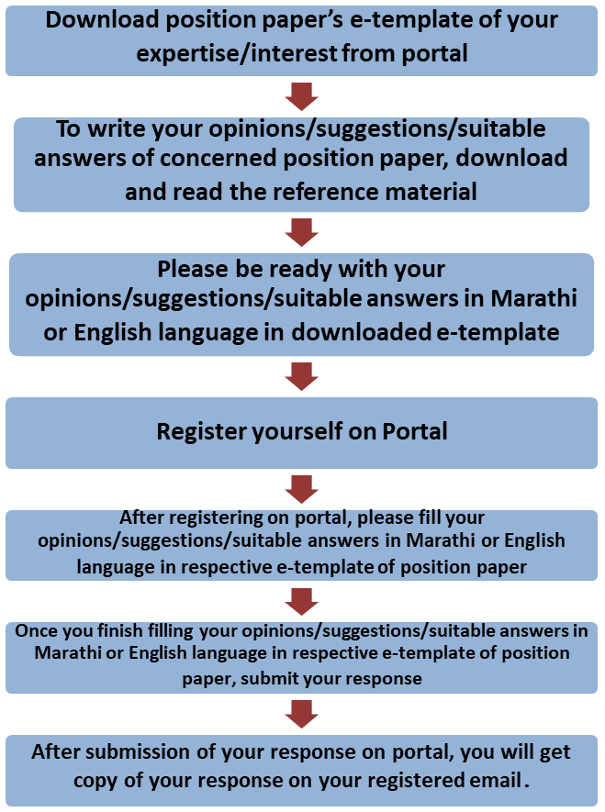

Last date of filling of your response is 30th May 2022

**Curriculum Development Department,**

**State Council of Educational Research and Training, Maharashtra, Pune**

# Vocational Education

**e-Template for the Position Paper of the Focus Group**

1. **Preliminary information**

This section contains preliminary information regarding the focus group.

* 1. **Executive Summary/Abstract** (0-500 words)

1. **Introduction**
   1. **Introduction to Vocational Education**

(What is the present status/position regarding Vocational Education? This also needs to include a brief on historical perspective and prevailing practices at the National or State or UT level) (0-300 words)

# National Education Policy 2020 and Vocational Education

(Please respond to the NEP 2020 points on vocational education, including any suggestions you may have regarding additions or modification #1) (0-300 words)

# Current Challenges

(What are the problems currently faced in vocational education? #2) (0-300 words)

# Addressing Current Challenges

(How can we ensure in the new curriculum and pedagogy that the problems listed in

2.3 are addressed/overcome? What is currently being done well in vocational education, and how can these present good practices/innovations/initiatives be strengthened/scaled up? #3 and #4) (0-300 words)

# Curriculum and Pedagogy of Vocational Education: Cross-Cutting Themes

* 1. **Integrating vocational aspects into the academic areas of the curriculum**

(NEP 2020 envisions vocational education as not merely preparation for livelihood but as a form of understanding and engagement that enables experiential learning. What should be the approach to incorporating vocational aspects of education across all the stages of schooling? What would be the curricular approach to ensure that there is no hard separation between vocational and academic streams in the school curriculum? How will vocational aspects be integrated into the academic areas of the curriculum? How would the curriculum ensure that all children have access to all vocational courses on offer? #5 and #7) (0-600 words)

# Identifying and Strengthening Core aspects of Vocational Education

(Which aspects of Vocational Education need to emphasised from Class VI onwards? How can these aspects be integrated into the curriculum to develop vocational skills

among children? How can the local context and the mapping of local needs and strengths be integrated? #15) (0-500 words)

# Determining the choice of vocations available to the students

(For vocational “exposure” what are the principles that would determine the choice of vocations available to the students? What would be the considerations for safety and appropriateness? How would the local contexts and economies influence these choices? #6) (0-300 words)

# Integrating Indian Knowledge Systems in Vocational Curriculum

(How will Indian Knowledge Systems be incorporated into vocational education? How would the curriculum develop respect among the students for local artisans and craftspersons? #10 and#11) (0-300 words)

# Hiring Local Master-Instructors

**(**What should be the approach for hiring local “master instructors” for vocational courses? What would be the criteria and qualifications of these instructors? How would they be prepared to engage with students in schools? What would be their service conditions? #9) (0-300 words)

# Planning Bagless Days

(How would the programmes of 10 bagless days and internships help in achieving goal of enhancing interests and skills of children in the area of Vocational Education#16) (SE,TE, AE) (0-300 words)

# Developmental Stages (5+3+3+4) and Science Curriculum

(The 4-stage design of Foundational (ages 3-8), Preparatory (ages 8-11), Middle (ages 11- 14), Secondary (ages 14-18) is critical for realizing the vision of NEP 2020. In this section, please give specific proposals and illustrations for the 4 stages of this curricular area)(0 - 200 words)

* 1. **Core Learning Objectives of Vocational Education** *(What are the core learning objectives and outcomes, i.e., key concepts, skills, values, dispositions, and capacities, that all students must develop in this subject by Grade 12? How should these capacities be developed across each stage (Foundational, Preparatory, Middle, Secondary? #17)*(0 -200 words)

## Foundational stage (0 -200 words)

* + 1. Preparatory stage (0 -200 words)
    2. Middle stage (0 -200 words)
    3. Secondary stage
       1. Classes IX and X (0 -200 words)
       2. Classes XI and XII (0 -200 words)
  1. **Pedagogy for the achieving Learning Outcomes in Vocational Education** (For each of the concepts/capacities *and stages described in 4.1 (or for as many as possible), describe, stage-wise, experiential/ play-based/ toy-based/ discovery-based/ experiment-based/ art-based/ sports-based/ storytelling-based/ interactive/ less- textbook-centric /creative/ enjoyable activities and pedagogy that will enable students to develop these capacities through less rote and greater creativity and analytical/critical thinking. #18*)(0 -200 words)

## Foundational stage (0 -200 words)

* + 1. Preparatory stage (0 -200 words)
    2. Middle stage (0 -200 words)
    3. Secondary stage
       1. Classes IX and X (0 -200 words)
       2. Classes XI and XII (0 -200 words)
  1. **Multidisciplinary and Interdisciplinary Experience in Vocational Education** (*Describe how to develop useful/interesting/illuminating horizontal connections in the curriculum and pedagogy of this subject (with other subjects and with “real life”) for each of these concepts (or for as many of these concepts as possible) that would promote a more holistic and multidisciplinary experience for students.#19*)(0 -200 words)

## Foundational stage (0 -200 words)

* + 1. Preparatory stage (0 -200 words)
    2. Middle stage (0 -200 words)
    3. Secondary stage
       1. Classes IX and X (0 -200 words)
       2. Classes XI and XII (0 -200 words)
  1. **Stage-wise integration of Indian Knowledge Systems in Vocational Education** *(Describe ways in which each of these concepts (or as many as possible) can be rooted in India, such as through Indian and local traditions (including stories, poems, music, dance, drama, games, toys, etc). And Knowledge Systems. #20)*(0 -200 words)

## Foundational stage (0 -200 words)

* + 1. Preparatory stage (0 -200 words)
    2. Middle stage (0 -200 words)
    3. Secondary stage
       1. Classes IX and X (0 -200 words)
       2. Classes XI and XII (0 -200 words)
  1. **Local Knowledge in Curriculum and Pedagogy**

(How will local and relevant tribal knowledge systems be incorporated into vocational education? Describe ways in which local knowledge and flavor could be included in the curriculum and pedagogy of this subject area. #12 and #21) (0 -300 words)

# Inclusion for Children with special needs

(What kinds of vocational education would be most relevant and appropriate for children with different disabilities? Approaches to inclusion for children from SEDGs that are necessary for this curricular area need to be elaborated.#14 and #24) (0-300 words)

# Assessment in Vocational Education

(What is the approach for designing appropriate assessments for vocational skills, values and capacities? Describe how assessment in the subject may be transformed from one that primarily tests rote memorisation skills to one that is more formative, promotes learning and development, and tests higher-order capacities such as analysis, critical thinking, and conceptual clarity. Assessment should respond to the need for being formative and competency based and promoting learning. Different modes of assessment that are age appropriate should be illustrated for each stage. #8 and #25) (0-400 words)

## Foundational stage (0-200 words)

* + 1. Preparatory stage (0-200 words)
    2. Middle stage (0-200 words)
    3. Secondary stage
       1. Classes IX and X (0-200 words)
       2. Classes XI and XII (0-200 words)
  1. **Vocational Education and Multilingual Perspective**

(Describe practices by which students may achieve bi- or multilingual proficiency in the discussion of this subject. #23) (0-300 words)

# Time allocation for science in school time table

(Time to be allocated (in percentage) for vocational education in the time table across the stages also keeping in view bag-less days-internship, practical’s, experiential learning, etc.?) (0-300 words) (SE, TE)

# Family and Community Participation in Vocational Education

(Describe ways in which families and local communities could be involved in the teaching and learning of this subject area #22) (0-300 words)

# Educational Technology for Vocational Education

(How can technology be used to promote accessibility/exposure to vocational education? Describe ways in which technology could be used to enhance teaching-learning in this subject in an effective and equitable manner? #13 and #27) (0-300 words)

# Teacher Capacity Building

**(**How should teacher capacity, support, and education be reformed to effectively enable all the above transformations? #28) (0-300 words)

# Enabling Conditions for Quality Vocational Education

(What enabling conditions (e.g., school culture, practices, infrastructure, equipment, governance, etc.) should be in place in order to effectively enable all the above transformations? #29) (0-200 words)

## School Culture and Practices (0-200 words)

* 1. Infrastructure and Equipment (0-200 words)
  2. Human Resource – Teaching as well as supporting (0-200 words)
  3. Teaching Learning Material (0-200 words)
  4. Technology related (0-200 words)
  5. School Governance(0-200 words)
  6. School Complex (0-200 words)
  7. Any other (0-200 words)

1. **Guidelines for Textbook and TLM Developers**

(Describe the approach to the textbook and TLM development keeping in mind the curricular and pedagogical shifts #26)(0-300 words)

## Foundational stage (0-200 words)

* 1. Preparatory stage (0-200 words)
  2. Middle stage (0-200 words)
  3. Secondary stage (0-200 words)

1. **Role of various agencies for providing quality Vocational Education in Schools**

(What are the roles that various agencies, for example, State Institutes of Vocational Education (SIVEs), SIETs, SCERTs, DIETs, CTEs, IASEs, NIEPA, NCERT, KVS, NVS, CBSE, State

School Education Boards, Universities, SIEMAT, etc., can play in the implementation of Vocational Education?) (0-200 words)

## Local organisations (0-200 words)

* 1. State level organisations (0-200 words)
  2. National level organisations (0-200 words)
  3. Any other (0-200 words)

1. **Specific Recommendations for the National/State Curriculum Frameworks**

(What are your specific recommendations for four curriculum frameworks with regard to science education?) (0-300 words)

## Specific recommendations for NCF/SCF ECCE (0-200 words) 10.2Specific recommendations for NCF/SCF SE (0-200 words) 10.3Specific recommendations for NCF/SCF TE (0-200 words) 10.4Specific recommendations for NCF/SCF AE (0-200 words)

1. **Any other comments and suggestions on this theme**

(In this subsection, please provide other suggestions about vocational education that are not covered in the above questions. It is recommended that these suggestions are in alignment with the vision and specific anchors provided above from the NEP 2020). (0- 300 words)

# Bibliography and References

(Please include references (books, research papers, studies, pilots, resource material, anecdotal evidence etc.) throughout to help substantiate recommendations wherever possible/applicable, with a bibliography for easy referencing)

***(Here, the system will allow the user to insert references in the APA format while filling up the document and will collate all the references in this section.)***

## Filled by system.

Annexures

(Not mandatory. Please put in a title for an annexure along with a one-line description)